**10th Passed from Board of Secondary Education 2017**

Pratap Public School, Sanganer, Jaipur

Currently Pursuing BCA(Bacholer of Computer Application).

I have good knowledge of computer hardware and software along with electrical work. I have also been working on social media for quite some time including website blog and YouTube videos.

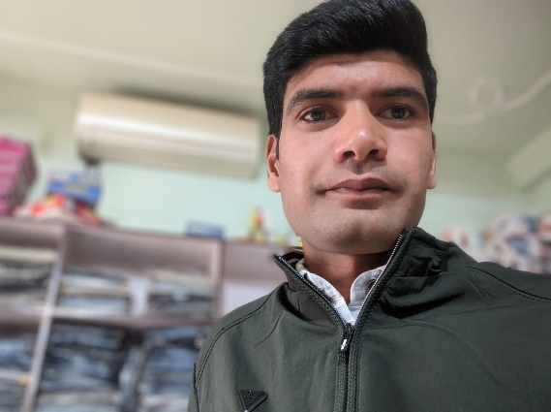

**Programming Languages**

C, C++, HTML, CSS, JAVA SCRIPT

PYTHON, DART

**IDE**

Android Studio

**Currently Pursuing BCA**

University of Technology

**12th Passed from Board of Secondary Education 2019**

Pratap Public School, Sanganer, Jaipur

**Objective**

**Education**

**Technical Skills**

**Skills**

**Language**

Gourav_bagda

@Gourav Bagda

Gouravbagda

Gourav Bagda



**Email**

Gouravbagda26@gmail.com

**Address**

Sanganer, Jaipur, Rajasthan, 302029

**Phone**

+91 97333 97333

**Date of Birth**

25/12/2002

**Web Designer**

**Gourav Sharma**

English & Hindi

Presentation

Client Acquisition

Team Management

Project Management